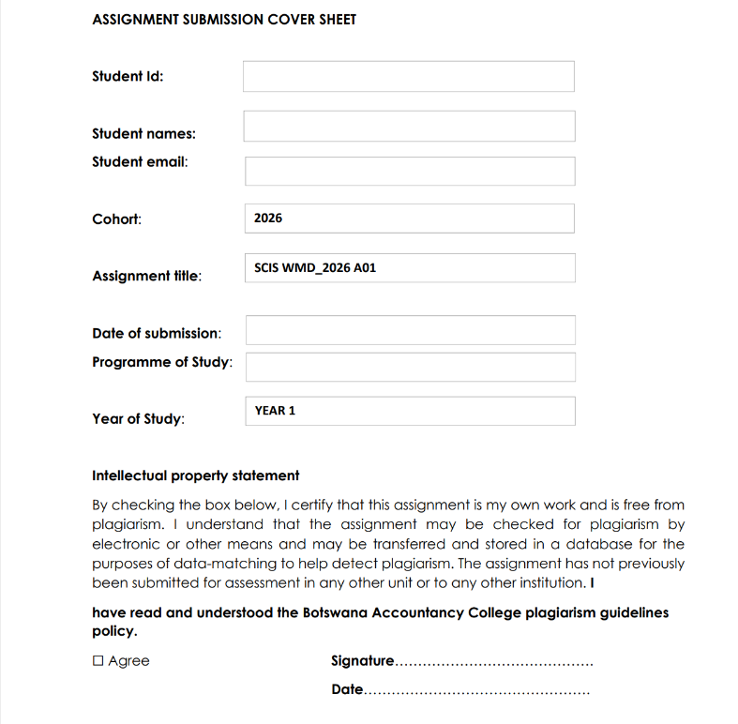
KATSO KGOSIETSILE SEKHUTE
Computer System Engineering
20/03/26
Cse25-333@thuto.bac.ac.bw
CSE25-333

WEB SPECIFICATION

BRAND NAME: TEART
Objective of my website: To showcase my digital art skills to potential business owners, entertainment industry and home owners.
Goal: To receive future collaboration and business deals and orders for example

- Designing unique and authentic logos for business owners in Botswana and South Africa, promoting authenticity and connection with humans.

- Creating vibrant imaginative wall art pieces for home owners, expressing the mood of the atmosphere and emotions that enhances the owner’s architecture interior beauty.

- Crafting personalised digital art portrait to entertainers e.g. Tyla (the talented artist) in order to showcase their natural beauty and adding a touch of my personal elements, in order to let them know that they are a flawless work of art and a masterpiece.

TARGET AUDIENCE

Demographics for Batswana Business Owners
- Business owners in Botswana (Gaborone) and South Africa (Johannesburg, Rustenburg and Pretoria)
For BOTSWANA
  - AGE- 18 to 45
  - Reading and Vocabulary level: have level A2 to B2 type pf English and Setswana which is officially recognized as a local language
  - Social class: Middle class
  - Location: Gaborone
  - Gender: Inclusive for both Male and Female

Technical aptitude for Batswana Business owners
Digital literacy: They are familiar with the latest tech gadgets, but majority of them use flagship phones and laptops with decent processors. Usually, business people spend less time on social media
Graphic skills: Lack of talent for making appealing visual designs logos and graphics. In addition, they rely on the use of generative AI because they are self-aware that they aren’t gifted enough and patient to at least effort in it.
They have access to decent 4G/5G internet and mobile data.
Device mostly used: smartphones and laptops
Social media mostly used: TikTok, which has a potential to reach 30k of people in Gaborone by using filtering hashtags like #Foryou #Botswana. However, short attention span is observed as it takes one second to scroll.
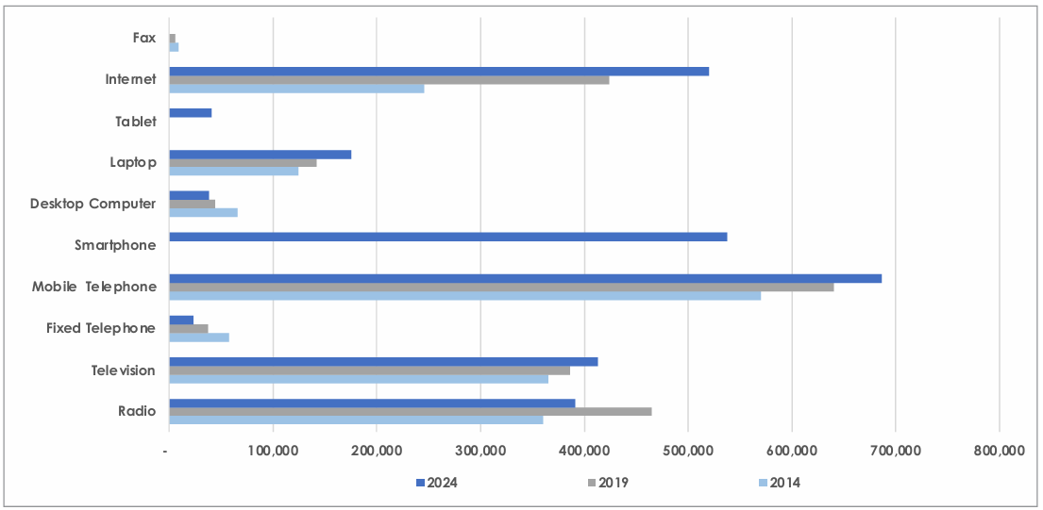

Demographics For South Africa Business owners
Age: 21-35
Reading Level: Can understand a wide range of indigenous languages like isiZulu, Sotho, Tswana, Pedi and Tsonga, Ndebele, Swati, Afrikaans, Venda, English and surprisingly sign language
Social class: Lower to upper middle class
Location: Johannesburg and Pretoria
Gender: Male, female, non binary and intersex which is officially recognized in the country

Technical aptitude: South African business owners
Access to Starlink and 4g/5G internet
Level of ecommerce: In South Africa Ecommerce is rapidly increasing to a point social media apps like Facebook, TikTok and Instagram which has a potential to cover 65.5 million of its total population, by using hashtags like #Foryoupage #explorepage #Southafricantok #Sama
Majority of south Africans use latest iPhone and prominent laptops .However, just like Batswana, South Africans may also have short attention span .

Demographic for Botswana HOME owners
Age: 30 to 40s
Reading Level: Multilingual in Simplified English and Setswana
Social class: Middle to Upper class
Location: Gaborone, Phakalane estates, Block 10 setlhoa estates, Tsholofelo east.
Gender: mostly single and independent women

Technical aptitude for South African Home owners

Social media mostly used: Facebook since
They have access to quality and stable WIFI connection. Unfortunately, they are not comfortable with experimenting with the latest technological features and prefer simple minimalistic navigation.
From observation they range from using mid-tier budget friendly phones e.g. Samsung a series to top flagship phones like iPhone 16, Samsung s23 ultra and majority of them have laptops that they use for corporate and online ordering.

- Entertainers (Musicians, Content creators, Influencers, Actors)

Demographics for Batswana entertainers
- Age: 20 to 30s
- Comprehension level and skills: Can read basic English comprehension and articulate themselves in everyday conversations and fluent in Setswana
- Social class: Middle class
- Location: Gaborone, Palapye, Mahalapye, Tonota, Francistown, Tlokweng
- Gender: Male and Female
- Level of education: No shade, unfortunately majority of them finished in form 3 and 5 and did not manage to proceed to college/ university. A few did manage to pursue marketable traditional degrees at prominent universities for job security

Technical aptitude for Batswana Entertainers
Technology gadgets: Majority of them use mass produced budget friendly Samsung A series, Techno and Redmi phones which have blurry camera quality pictures and videos. Majority of them barely use laptops
From observation, the most social media app used to promote their works is mostly Facebook as it is the most used app in Botswana which have a potential of capturing most of Facebook users ranging from gen z to earlier generations like boomers, followed by TikTok, where the creation of short dancing clips go viral, by using the hashtags #Foryoupage which can position them in a place where they can get a few gigs to perform at events
Unlimited internet access is limited as mobile data from Orange, Bemobile and Mascom is currently used.

INFORMATION DESIGN AND TAXONOMY
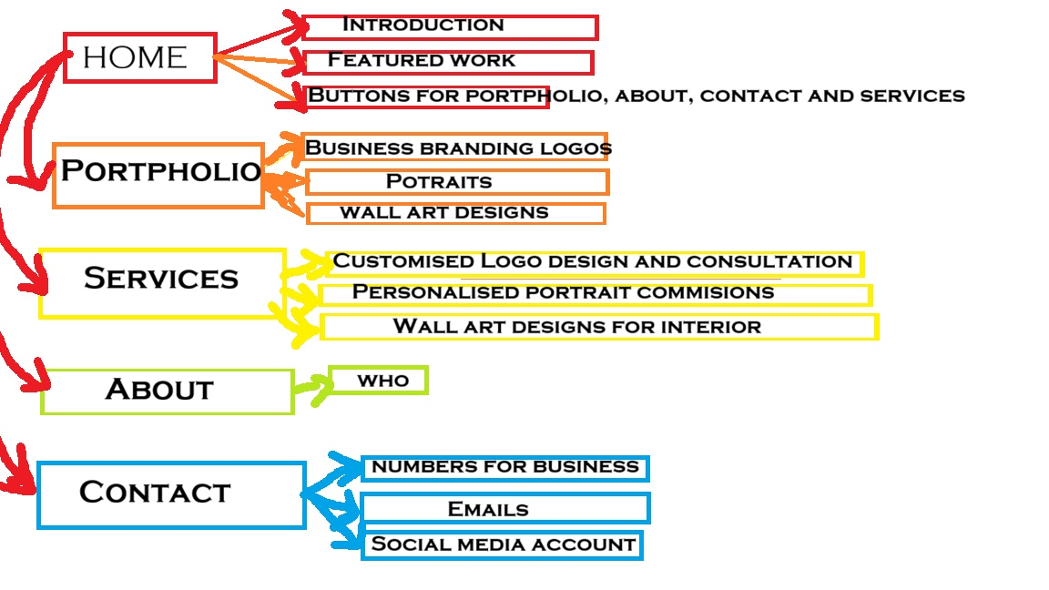

TECHNICAL BRIEF
Tools used
IbisX paint- to create and design lettering, logos and graphics and brushes for potrait designs
GitHub- for creating a repository and host the live website
W3cvalidator- to check the errors
Visual studio code for debugging, highlighting syntax errors
Autodesk sketch to add glowing brushes,
Pixel art to create pixelated drawings from scratch

References
BRIEF, S., 2025. Botswana Household Access and Individual use of ICTs. STATISTICS BOTSWANA.
Country Report for Botswana - Internet Society Pulse
https://pulse.internetsociety.org/en/reports/BW/
Botswana Demographics 2026 (Population, Age, Sex, Trends) - Worldometer
https://www.worldometers.info/demographics/botswana-demographics/
South Africa Demographics 2026 (Population, Age, Sex, Trends) - Worldometer
https://www.worldometers.info/demographics/south-africa-demographics/
Country Report for South Africa - Internet Society Pulse
https://pulse.internetsociety.org/en/reports/ZA/
South Africa's online retail sales to exceed $7.42 billion this year, study forecasts | Reuters
https://www.reuters.com/world/africa/south-africas-online-retail-sales-exceed-742-billion-this-year-study-forecasts-2025-09-11/
Strauss & Co Total Art Sales Increase by 26% in 2025 - Strauss & Co
https://www.straussart.co.za/2026/strauss-co-total-art-sales-increase-26-in-2025

